AI-Augmented Backend Development
Project :
TITLE : AI -FitTrack

Project Description
FitTrack is an AI-Augmented Gym Management Web Application developed using the **MongoDB, Express.js, Node.js, and HTML/CSS/JavaScript** technologies, integrated with Artificial Intelligence capabilities such as an **AI Fitness Coach, intelligent recommendations, and personalized fitness guidance**. The system enables users to register and manage their profiles, access membership and subscription services, receive AI-based fitness suggestions, submit feedback, and communicate with the gym through contact services. Administrators can manage registered users, memberships, subscriptions, feedback, and gym operations through a dedicated dashboard. By combining traditional full-stack backend development with modern AI technologies and database-driven services, FitTrack provides a **dynamic, secure, scalable, and userfriendly platform** that improves gym management, personalized fitness support, and overall user experience.

Scenario
Many people struggle to maintain a consistent fitness routine because they do not have personalized guidance, proper workout plans, or an easy way to track their daily fitness activities. Traditional fitness methods often depend on trainers, manual record keeping, or general workout plans that do not consider an individual’s specific needs and progress. This can make it difficult for users to monitor their activities, understand their performance, and stay motivated.
Artificial Intelligence can improve this process by providing personalized and intelligent fitness assistance. AI FitTrack is designed to help users manage their fitness activities through AI-powered features. The application can provide personalized recommendations, answer fitness-related questions through an AI chatbot, generate suitable workout or fitness content, and provide intelligent insights based on the user’s activity and progress. These capabilities reduce the limitations of manual tracking and provide users with a more personalized fitness experience.
The proposed AI FitTrack application combines fitness tracking with AI capabilities such as AI Chatbot, Question Answering, Content Generation, Intelligent Recommendations, Semantic Search, Vector Search, and AI-powered Insights. The system can understand user queries, provide relevant fitness guidance, recommend suitable activities, and analyze available fitness information to generate useful insights. This helps users make better-informed decisions about their fitness routines and maintain their progress more effectively.

Identify the Problem
Users often find it difficult to track fitness activities, follow suitable workout plans, and get personalized guidance. Traditional systems mainly depend on manual tracking and fixed plans.

Explain the Need for AI
AI can understand user needs, analyze fitness data, answer questions, and provide personalized recommendations. This makes fitness management more efficient and user-friendly.

Describe the Proposed Solution
AI FitTrack uses AI Chatbot, Question Answering, Content Generation, Semantic Search, Vector Search, Intelligent Recommendations, Document Analysis, and AIpowered Insights to provide personalized fitness guidance and help users track and improve their fitness progress.

Structure:
Paragraph 1 – Problem:
Many users find it difficult to track their fitness activities, follow proper workout plans, and get personalized guidance. Traditional fitness systems mainly depend on manual tracking and fixed workout plans.
Paragraph 2 – AI Solution:
AI FitTrack uses Artificial Intelligence to provide personalized fitness support through an AI Chatbot, Question Answering, Content Generation, Intelligent Recommendations, Semantic Search, Vector Search, and AI-powered Insights.
Paragraph 3 – Impact:
The application benefits fitness users by making fitness tracking easier and more personalized. It helps users understand their progress, receive suitable recommendations, and maintain a consistent fitness routine.
System Requirements :
To ensure smooth development, deployment, and usage of the AI FitTrack AIAugmented Backend Application, the following software requirements are needed.

1. Software Requirements
Operating System
- Windows 10/11
- macOS
- Linux Node.js (v18 or above)
Provides the runtime environment for the backend.
npm (v9 or above)
Used for installing and managing project dependencies.
Express.js
Used to develop backend APIs and server-side functionality.
MongoDB / MongoDB Atlas
Used to store:
- User information
- Fitness data
- Chat history
- AI interactions
- Application data
MongoDB Atlas Vector Search
Used for semantic search and retrieving relevant fitness information using AI embeddings.
AI Service Provider
- OpenAI API / Gemini API
- Claude API
- Azure OpenAI (Optional)
LangChain / AI SDK
Used to manage and integrate AI workflows.
Postman
Used for testing backend APIs.
Visual Studio Code
Used as the development environment.
Web Browser
- Google Chrome
- Mozilla Firefox
Git & GitHub
Used for source-code management and version control.

2. Hardware Requirements
Processor
Intel Core i5 (8th Gen+) / AMD Ryzen 5+
RAM
Minimum 8 GB
Recommended 16 GB
Storage
Minimum 5 GB Free Space
Internet Connection
Required for AI API communication
Display
1366 × 768 or above

Project Architecture
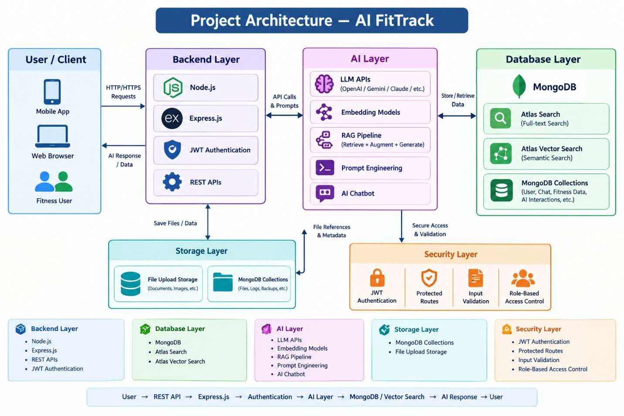

ER Diagram
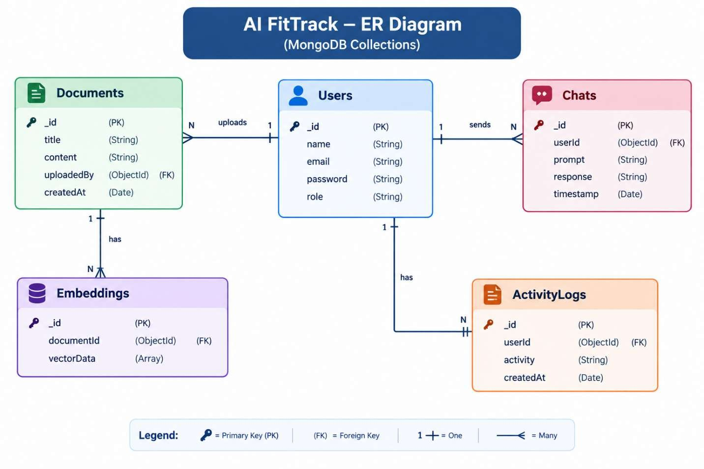

ER Diagram Explanation
Users can register, log in, and securely access AI FitTrack using JWT authentication. Users can upload fitness documents, which are processed into embeddings for AIbased search and analysis.
The system stores chat interactions and AI responses in the Chats collection and records user activities in ActivityLogs. These collections support AI Chat, Vector
Search, Question Answering, RAG, Content Generation, and Intelligent Insights.

Features

Core Backend Features
- User Registration & Login
- JWT Authentication
- Protected Routes
- Middleware
- CRUD API
- File Upload
- Role-Based Access Control

AI Features
- AI Chat Assistant
- Semantic Search & Vector Search
- Fitness Question Answering
- Content Generation
- RAG (Retrieval Augmented Generation)
- Intelligent Insights
- Natural Language Queries

Roles and Responsibilities
The AI FitTrack backend supports one primary role: Authenticated User.

Responsibilities

- Register an account.
- Login securely.
- View profile information.
- Add workout records. • View workout history.
- Search workouts.
- Update workout records.
- Delete workout records.
- Request AI workout recommendations.
- Request AI fitness insights.

Permission

Operation | Permission
Register | Yes
Login | Yes
View Profile | Yes
Add Workout | Yes
Get Workouts | Yes
Search Workouts | Yes
Update Workout | Yes
Delete Workout | Yes
AI Recommendations | Yes
Fitness Insights | Yes

Admin
- Manage Users
- Manage Documents
- Monitor AI Usage
- View Analytics ● Configure System

User
- Register/Login
- Upload Documents
- Ask Questions
- Search Content
- View AI Recommendations
- Manage Personal Data

User Flow

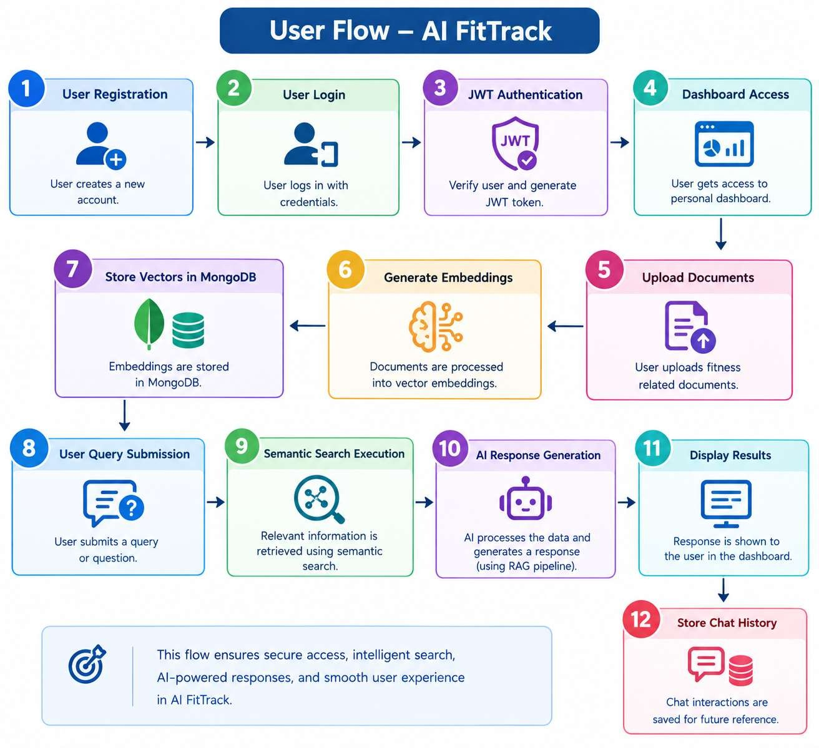

MVC Pattern
The AI FitTrack backend follows the MVC (Model–View–Controller) architecture to organize the application into separate components.

Model
Handles database structure and data operations using MongoDB/Mongoose.
- User Model
- Workout Model
- Chat Model
- Activity Model

View
Represents the response sent to the client through REST APIs, mainly using JSON data.

Controller
Handles business logic and connects the Model with API requests.
- User Authentication
- Workout Management
- AI Recommendations
- Fitness Insights
- Chat Processing

MVC Flow
User → Route/API → Controller → Model → MongoDB → Controller → JSON
Response → User

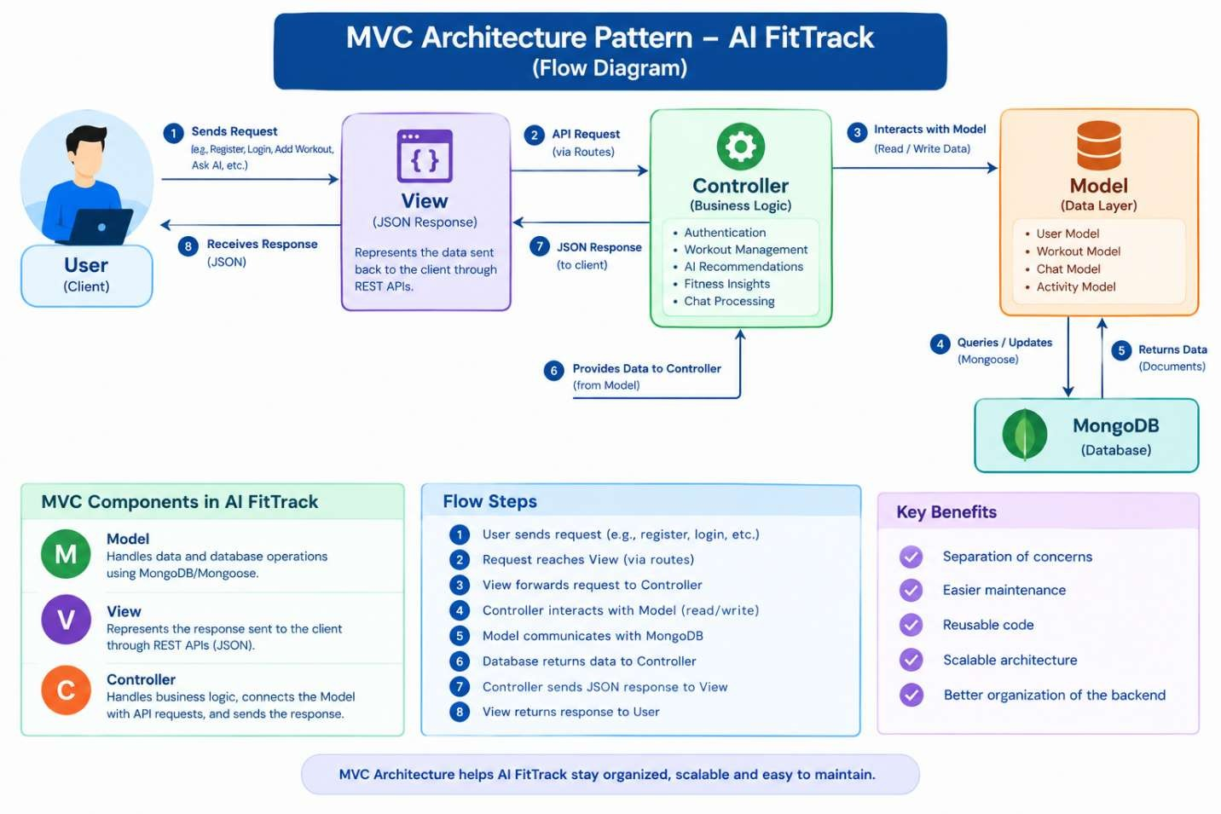

MVC Architecture – AI FitTrack

Model Layer
Responsible for managing application data using Mongoose.

- User Schema
- Workout Schema
- Chat Schema
- Activity Schema
- Fitness Data Schema

Controller Layer
Responsible for handling business logic.

- User Authentication
- Workout Management
- AI API Integration
- AI Recommendation Generation
- Fitness Insights
- Search Operations
- CRUD Operations

View Layer (Routes)
Defines REST API endpoints.

Authentication Routes
- Register
- Login • Logout

Workout Routes
- Add Workout
- View Workouts
- Update Workout
- Delete Workout
- Search Workouts

AI Routes
- AI Chat
- Workout Recommendations
- Fitness Insights
- Fitness Question Answering

User Routes
- View Profile • Update Profile
- Dashboard

Advantages of MVC
- Separation of Concerns
- Better Maintainability
- Easy Scalability
- Reusable Components
- Easier Testing
- Better Backend Organization

Project Setup and Configuration
The AI FitTrack backend project is set up using Node.js and Express.js. The project is organized into separate folders for models, controllers, routes, middleware, configuration, AI services, and utility functions. This structure makes the backend easier to develop, maintain, and scale.
The project is initialized using npm, and required dependencies such as Express, Mongoose, JWT, dotenv, and AI SDKs are installed. MongoDB is configured as the database, while environment variables are used to securely store database and AI API credentials.

Creating Project Folder

Step 1: Create the Project Folder
Create a new folder with the project name.
AI-FitTrack
Step 2: Open the Project
Open the project folder in Visual Studio Code.

Step 3: Create the Server Folder

Inside the project directory, create a folder named: server
All backend source code and server-related files will be maintained inside this folder

mkdir server
cd server npm init -y

Step 4: Initialize Node Project

Open the terminal inside the server folder and execute:

npm init -y

This command generates the package.json file, which contains project metadata, scripts, and dependency information.

Step 5: Install Required Packages

Install the required backend dependencies:

npm install express mongoose dotenv bcryptjs jsonwebtoken cors

Install Nodemon as a development dependency:

npm install --save-dev nodemon

These packages are used for creating the API server, connecting to MongoDB, managing environment variables, securing passwords, implementing authentication, and handling cross-origin requests.

Environment Variables
Sensitive information and configuration values are stored in the .env file.

Example
PORT=5000
MONGO_URI=mongodb://localhost:27017/aifittrack
JWT_SECRET=your_secret_key GEMINI_API_KEY=your_google_gemini_api_key

Using environment variables improves security by preventing sensitive information such as database credentials, JWT secrets, and API keys from being directly exposed in the source code.
The .env file should not be committed to the project repository.

Create:
server.js
models/ controllers/ routes/ middlewares/ config/ services/ utils/


Install Backend Packages
npm install express mongoose cors dotenv bcryptjs jsonwebtoken

npm install openai

npm install multer

npm install nodemon --save-dev


Backend Development
The AI FitTrack API backend is developed using Node.js, Express.js, MongoDB, and
Mongoose. The backend provides APIs for authentication, fitness data management, AI-based recommendations, document processing, vector search, and chat functionality.
Include:
- Authentication APIs
- JWT Implementation
- AI Service Integration
- Vector Search APIs
- CRUD APIs
- Document Upload APIs
- Chat APIs
Video Link:
https://drive.google.com/file/d/1u_5KLD-h8lE6fjk8hR2ve72OabBy7-jl/view?usp=drive_link

Database Development
Include:
● MongoDB Collections
● Relationships
● Atlas Search Index
● Vector Search Index
● Sample Documents

Project Execution Step 1: Backend
cd server
npm install


Step 2: Configure Environment Variables
Create .env
PORT=8000

MONGO_URI=mongodb://localhost:27017/ai_augmented_db

JWT_SECRET=your_secret_key

OPENAI_API_KEY=your_api_key


Step 3: Run Backend
nodemon server.js
Backend URL:
http://localhost:8000


Output Screenshots with Explanation

- API Testing

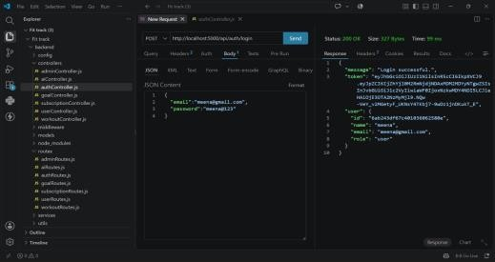

Explanation:
The screenshot shows the login API testing of the AI FitTrack application. A POST request is used to send the user's email and password to the login API. The server verifies the credentials and returns a 200 OK response along with an authentication token and user details, confirming that the login API is working successfully.

- Register Api

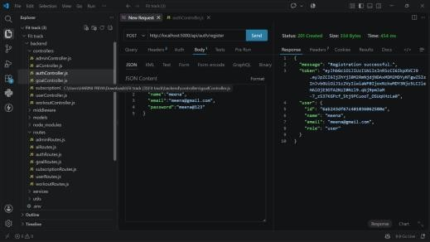

Explanation:
The screenshot shows API testing of the user registration function in AI FitTrack. A POST request sends the user's name, email, and password to the registration API. The 201 Created response confirms that the user was successfully registered, and the response returns the newly created user details and authentication token.AI Chat Interface

- Profile API
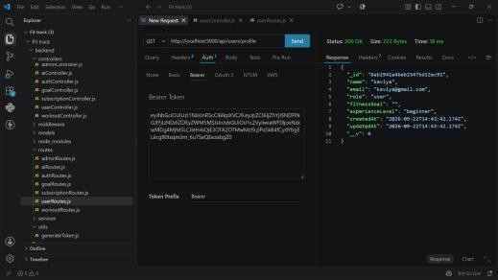

Explaination
The screenshot shows API testing of the user profile API in AI FitTrack. A GET request is used with a Bearer token to securely retrieve the user's profile details. The 200 OK response confirms that the profile data was successfully retrieved.

- Workout API
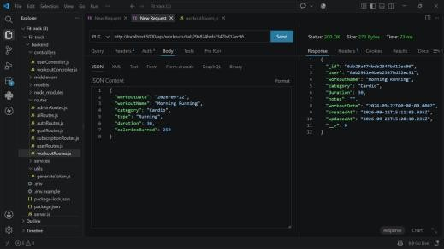
Explaination:
The screenshot shows API testing of the fitness data API in AI FitTrack. A POST request is used to send fitness details such as date, exercise, duration, and calories. The 200 OK response confirms that the fitness data was successfully processed and stored.

● LLM Integration
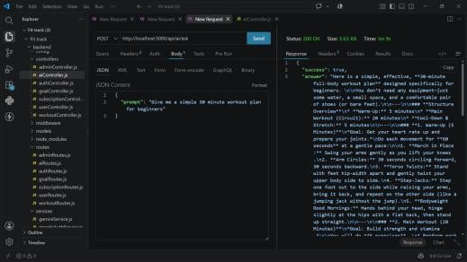

Explaination:
The screenshot shows API testing of the AI fitness assistant in AI FitTrack. A request is sent with a fitness-related question, and the API returns an AI-generated response with personalized fitness guidance. This confirms that the AI assistant API is working successfully.

Demo Video Link :
https://drive.google.com/file/d/1u_5KLD-h8lE6fjk8hR2ve72OabBy7-jl/view?usp=drive_link

Source Code Drive Link :
https://drive.google.com/drive/folders/1HpRy8v7VMIoCpQNftet4aq937rYFmm7m?usp=drive_link

